IRIS FLOWER CLASSIFICATION USING ARTIFICIAL INTELLIGENCE

Artificial Intelligence – Project 2

Submitted By

Name: Alishba Riaz
Batch: 2026

Abstract
Iris Flower Classification is a simple Artificial Intelligence and Machine Learning application that is created in Python programming language. The main purpose of this project is to classify iris flowers into different categories using supervised learning techniques. The system utilizes the famous Iris dataset which has the measurements of flowers, including sepal length, sepal width, petal length and petal width.
In the present project, the dataset is loaded and split into training and testing set by machine learning methods. The model is trained using a Decision Tree Classification algorithm. Following training, the model classifies the flower category based on the input features provided, and outputs the accuracy score, classification report and confusion matrix indicating model performance.
The project illustrates important Artificial Intelligence concepts including supervised learning, classification, data pre-processing, training the model, testing the model and prediction. It also gives hands-on experience on machine learning pipelines and enables beginner programmer to enhance their skills in programming and logical thinking with Python and Google Colab.
Keywords: Artificial Intelligence, Machine Learning, Classification, Supervised Learning, Decision Tree, Iris Dataset, Python, Google Colab

Table of Contents
Abstract 2
1. Introduction 4
2. Objective 4
3. Software Used 4
4. Dataset Used 5
5. Methodology 5
6. Python Code 11
7. Output Result 15
8. Working Principle 15
9. Advantages 16
10. Limitations 16
11. Conclusion 16

Introduction
Artificial Intelligence is one of the rapidly expanding computer science technology. Machine Learning is one of the areas of Artificial Intelligence that enables computers to learn patterns from data and make predictions on their own. Classification is one of the essential techniques of supervised learning which is applied to classify the data into a set of predefined classes.
This project has developed an Iris Flower Classification system with Python programming language and machine learning techniques. The data set Iris is the data used in this project, which contains measurements of the flowers of irises representing the different species. The machine learning model trains the flower patterns from the data and predicts the flower category according to flower measurements.
The algorithm used in this project is Decision Tree Classification algorithm because it is very easy to understand, very fast and is also recommended for beginners. The project is created using google colab and shows important concepts like handling of a dataset, supervised learning, splitting of data, training a model, predicting the outcome, evaluating accuracy, and visualization.
This project not only helps to build understanding of the concepts behind Artificial Intelligence (AI) and Machine Learning (ML), but also enhances the logical aspects of programming and its application.

Objective
The aims of this project are:
- To gain awareness of the fundamentals of Artificial Intelligence and Machine Learning.
- To apply supervised learning with a classification method.
- To load and analyze Iris data set.
- To split data into training and testing sets.
- To train Decision Tree Classification model.
- To determine the flower categories based on trained AI model.
- To analyze the performance of the model using accuracy score and confusion matrix.
- To gain experience in the real-life application of AI classification systems

Software Used
The following software and libraries are used in this project:
- Python
- Google Colab

Dataset Used
In this project, the Iris Flower Dataset is used. One of the more widely used datasets for machine learning classification problems. The data consists of 150 flower samples organized into three classes:
- Iris Setosa
- Iris Versicolor
- Iris Virginica
The dataset has 4 features:
- Sepal Length
- Sepal Width
- Petal Length
- Petal Width
These measurements are used by the AI model to predict the flower category.

Methodology
Iris Flower Classification project is developed with the supervised machine learning approach. The entire development process is broken down into various stages.
Step 1: Upload and Extract Dataset
First the data set is zipped and uploaded to Google Colab and then extracted with the Python zipfile library.
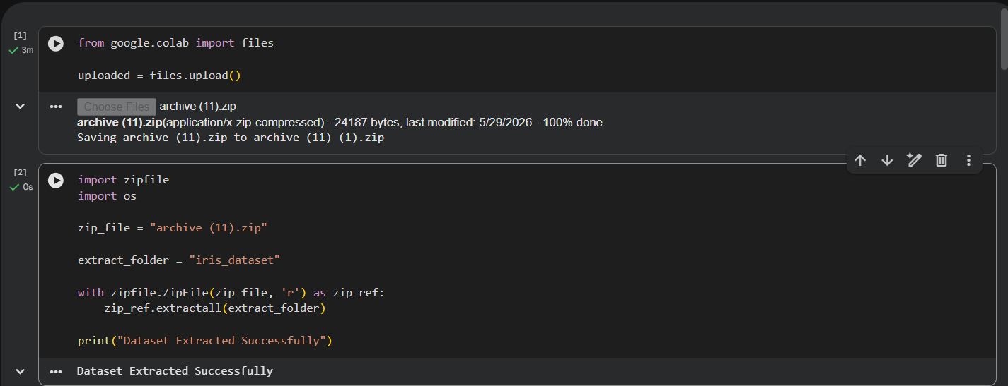
This step is done to prepare the data for further processing.
Step 2: Import Libraries
Importing of Python libraries like Pandas, NumPy, Matplotlib etc.Import of required python packages like Pandas, NumPy, Matplotlib, Seaborn, and Scikit-learn.
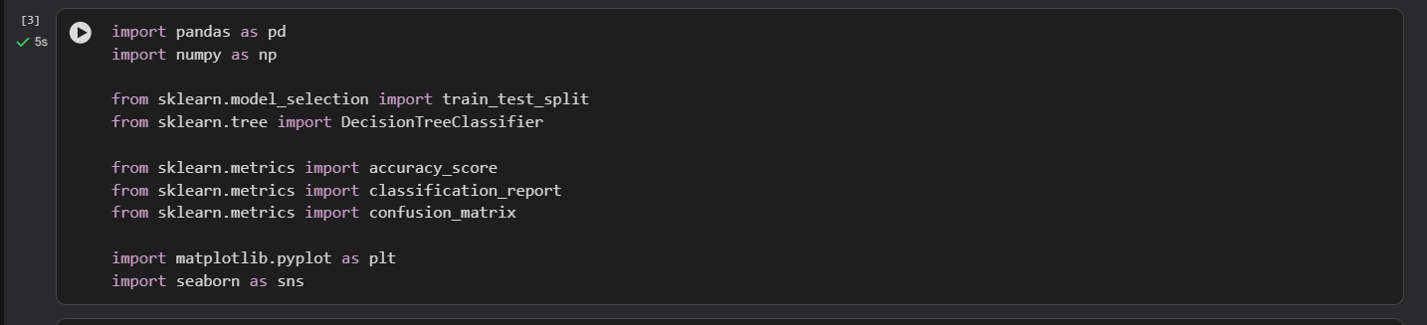
These libraries are used for data handling, visualization, machine learning and evaluation.
Step 3: Load Dataset
The Iris dataset CSV file is read in using pandas read_csv() function.
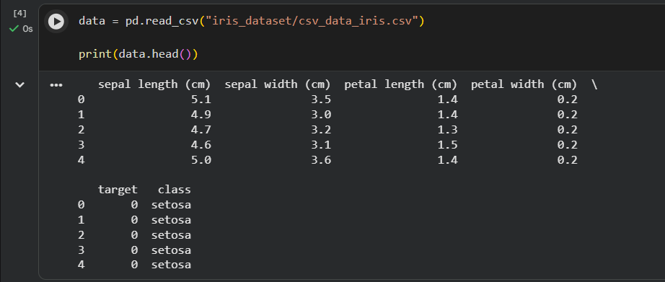
The data is saved in a dataframe to be processed and analyzed.
Step 4: Show the information regarding the data set
The information on the dataset, including the number of rows, columns, feature names and class labels is shown.
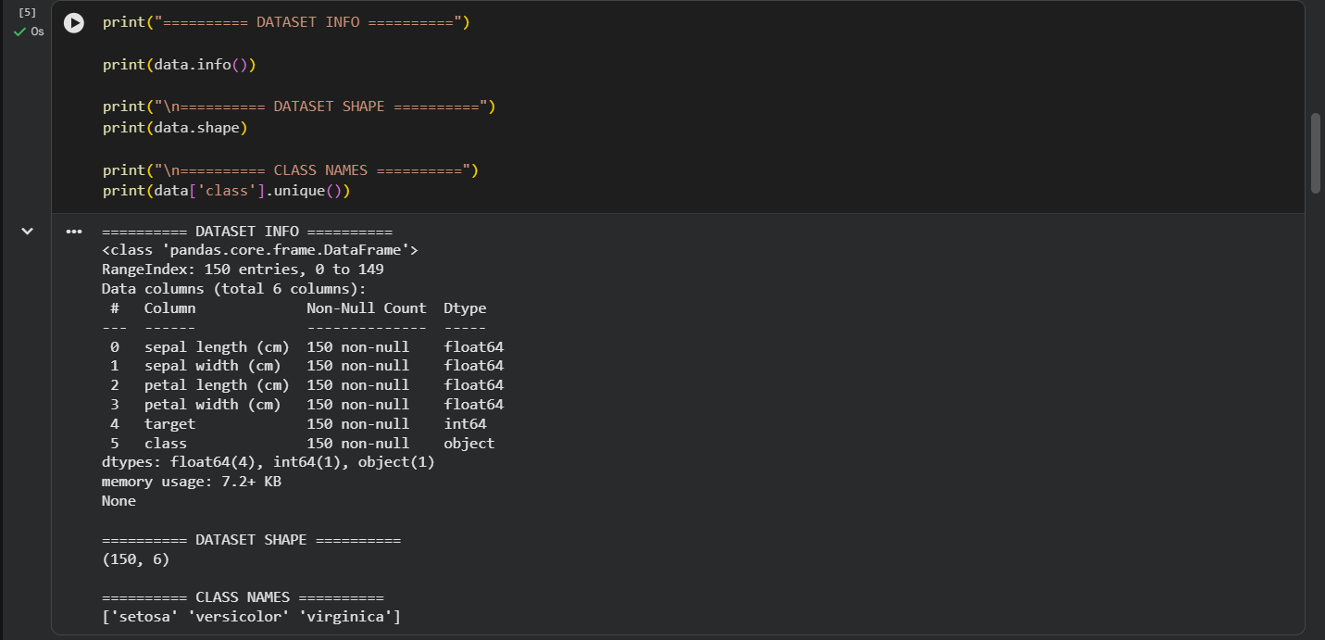
This is useful to understand the structure of the dataset.
Step 5: Data Preprocessing
The input features and target labels are separated.
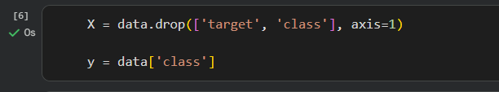
The features in the column are kept in variable x, and the flower categories are kept in variable y.
Step 6: Split Dataset
The data set is split into two sets: training set and testing set, using train_test_split() function. 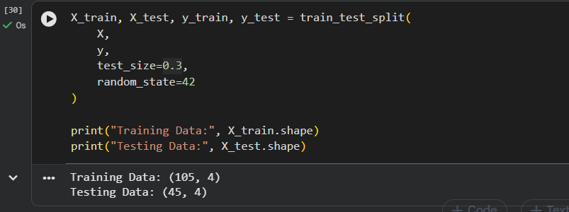
The model is trained on the training data and tested on the testing data.
Step 7: Create and Train AI Model
A Decision Tree Classification model is created using Scikit-learn library. Patterns are recognized by the model during training. The fit() function is used to train the machine learning model.
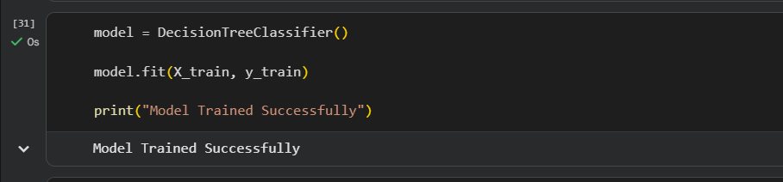
In the training phase the model finds the relationship between the input features and the flower class.
Step 8: Make Predictions
The trained model can be used to predict flower categories for testing data with the predict() function.
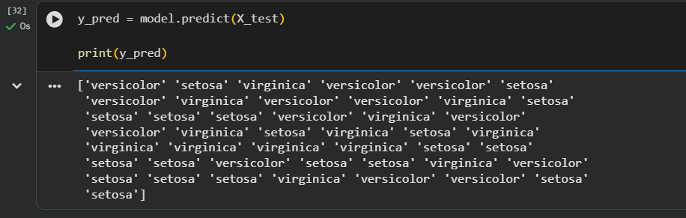
Step 9: Calculate Accuracy
The accuracy score is used for assessing the performance of the model.
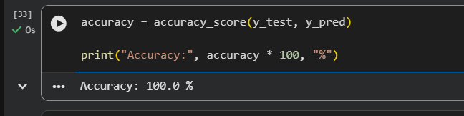
Accuracy reflects the model's ability to predict flower classes accurately.
Step 10: Classification report
A classification report is produced to show the precision, recall and F1-score of the model.
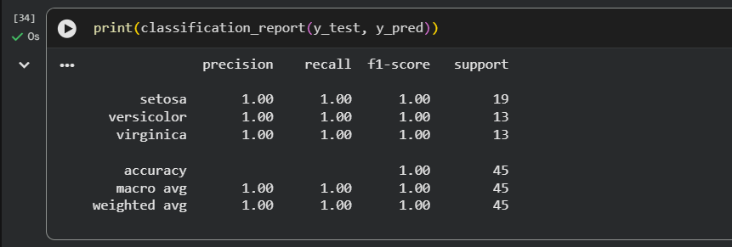
Step 11: Generate a Confusion Matrix
The confusion matrix is generated to obtain an actual class vs. predicted class comparison.
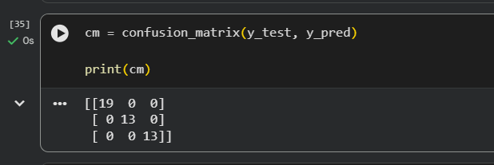
This is useful in interpreting the performance of the models in their predictions.
Step 12: Confusion Matrix Visualization
A heatmap from the Seaborn library and Matplotlib is used to plot the confusion matrix.
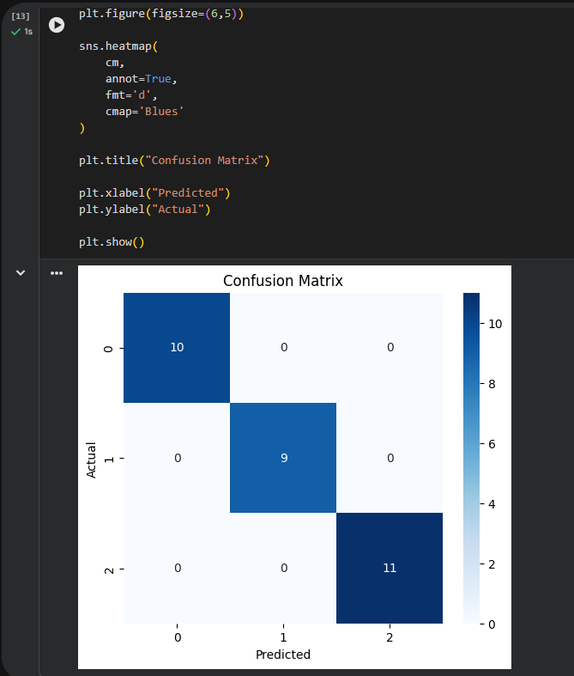
The graphical representation helps in better understanding the prediction performance of the classification model.
Step 13: Data Visualization
Using the Matplotlib and Seaborn libraries, a scatter plot graph is plotted to see how the sepal length and petal length of the Iris data are related. The graph distinguishes different flower species (Setosa, Versicolor, Virginica) with different colors.
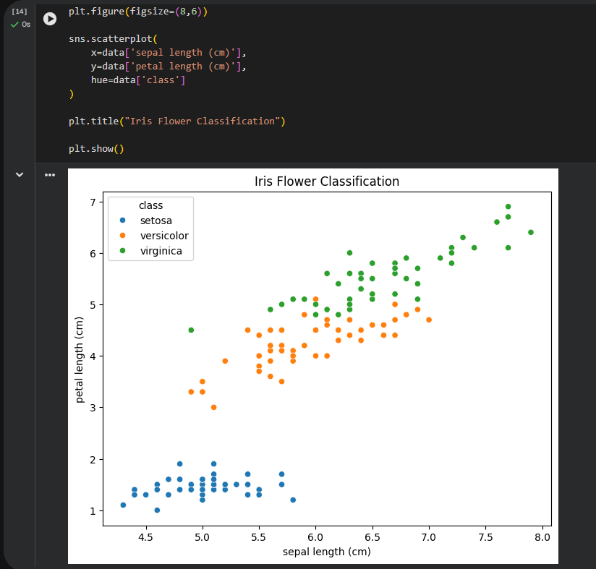
The visualization is used to identify the spread of flower classes and to visualize the classification of flower classes using values of features and the machine learning model.
Step 14: Custom Prediction
The trained Decision Tree Classification model is fed with a custom flower sample to make a prediction. Based on the feature values entered, the flower category is predicted using the model.
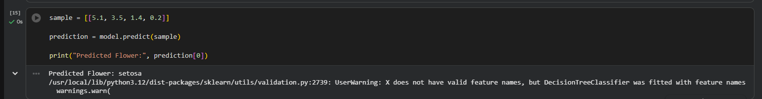
This step illustrates the ability of the trained AI model to classify new flower samples accurately, leveraging machine learning techniques.

Python Code
from google.colab import files

uploaded = files.upload()
import zipfile
import os

zip_file = "archive (11).zip"

extract_folder = "iris_dataset"

with zipfile.ZipFile(zip_file, 'r') as zip_ref:
zip_ref.extractall(extract_folder)

print("Dataset Extracted Successfully")

import pandas as pd
import numpy as np

from sklearn.model_selection import train_test_split
from sklearn.tree import DecisionTreeClassifier

from sklearn.metrics import accuracy_score
from sklearn.metrics import classification_report
from sklearn.metrics import confusion_matrix

import matplotlib.pyplot as plt
import seaborn as sns

data = pd.read_csv("iris_dataset/csv_data_iris.csv")

print(data.head())

print("========== DATASET INFO ==========")

print(data.info())

print("\n========== DATASET SHAPE ==========")
print(data.shape)

print("\n========== CLASS NAMES ==========")
print(data['class'].unique())

X = data.drop(['target', 'class'], axis=1)

y = data['class']

X_train, X_test, y_train, y_test = train_test_split(
X,
y,
test_size=0.3,
random_state=42
)

print("Training Data:", X_train.shape)
print("Testing Data:", X_test.shape)

model = DecisionTreeClassifier()

model.fit(X_train, y_train)

print("Model Trained Successfully")

y_pred = model.predict(X_test)

print(y_pred)

accuracy = accuracy_score(y_test, y_pred)

print("Accuracy:", accuracy * 100, "%")

print(classification_report(y_test, y_pred))

cm = confusion_matrix(y_test, y_pred)

print(cm)

plt.figure(figsize=(6,5))

sns.heatmap(
cm,
annot=True,
fmt='d',
cmap='Blues'
)

plt.title("Confusion Matrix")

plt.xlabel("Predicted")
plt.ylabel("Actual")

plt.show()

plt.figure(figsize=(8,6))

sns.scatterplot(
x=data['sepal length (cm)'],
y=data['petal length (cm)'],
hue=data['class']
)

plt.title("Iris Flower Classification")

plt.show()

sample = [[5.1, 3.5, 1.4, 0.2]]

prediction = model.predict(sample)

print("Predicted Flower:", prediction[0])

Output Result
Using the Machine Learning technique, the Iris Flower Classification system was able to classify iris flowers into different Iris categories. The trained model of Decision Tree was very accurate in predicting the data.
The project was able to demonstrate:
- Dataset information
- Model accuracy
- Classification report
- Confusion matrix
- Data visualization graphs
- Flower prediction results
The trained model was able to recognize flower classes according to flower measurement.

Working Principle
The Iris Flower Classification system makes use of supervised machine learning techniques. The system loads and processes the data set of flower measurements and pre-defined flower classes. The dataset is divided into training and testing data. The Decision Tree Classification model is taught about patterns and relationships between flower measurements and flower categories using the training data.
The model is trained and is used to predict flower categories for new data. The accuracy of model and their performance is evaluated by comparing the prediction result with actual classes. The confusion matrix and classification report are used to analyse the accuracy of the model in performing classification tasks. Data visualization is also employed to analyze the distribution of data and the behaviour of the models.

Advantages
Iris Flower Classification project offers a variety of benefits for AI and ML beginners.
- The project is easy to make and is suitable for beginners
- It is easy to understand the ideas of supervised learning in it
- Understands classification algorithms
- The project enhances programming and logical thinking skills
- It offers hands-on knowledge of machine learning processes
- The model has high classification accuracy
- Data visualization helps one understand the pattern of the data set

Limitations
The project works well with classification, but there are certain limitations that are present.
- The data set is relatively small and easy to handle
- The model cannot be trained to recognize new flower types
- The system will not be able to automatically learn from new data sets
- May be less accurate with complex real life data sets
- The project only utilizes one classification algorithm
- The system is unable to perform complex deep learning tasks

Conclusion
Implementation of Iris Flower Classification project has been successfully done in Google Colab with Python programming language and Machine Learning techniques. The project met all the stated aims of handling the data set, supervised learning, training the model, predicting data, and evaluating the performance of the model. The Decision Tree Classification model has managed to learn the Iris dataset and correctly classify the Iris flower categories based on its input features.
The project gave hands-on experience in studying the concepts of Artificial Intelligence including classification, supervised learning, data preprocessing, training, testing, and prediction systems. In conclusion, this project is a great stepping stone for the development of future advanced applications of AI and Machine Learning.

